Cheaha RegionaL Head Start

a Division of TCR Child Care Corporation

2022-2023 Annual Report
January 2023

Cheaha Regional Head Start
925 North Street
Talladega, AL 35160
256-362-1390

P

Purpose and Scope in alignment with the Head Start Performance Standards and The Head Start Act

1302.102 Achieving program goals
(c) Using data for continuous improvement. (1) A program must implement a process for using data to identify program strengths and needs, develop and implement plans that address program needs, and continually evaluate compliance with program performance standards and progress towards achieving program goals described in paragraph (a) of this section.
(2) Annually, a program must publish and disseminate a report that complies with section 644(a)(2) of the Act and includes a summary of a program’s most recent community assessment, as described in §1302.11(b), consistent with privacy protections in subpart C of part 1303 of this chapter.
Sec. 644. [42 U.S.C. 9839]

(a)(1) Each Head Start agency shall observe standards of organization, management, and administration that will ensure, so far as reasonably possible, that all program activities are conducted in a manner consistent with the purposes of this subchapter and the objective of providing assistance effectively, efficiently, and free of any taint of partisan political bias or personal or family favoritism. Each such agency shall establish or adopt rules to carry out this section, which shall include rules to assure full staff accountability in matters governed by law, regulations, or agency policy. Each agency shall also provide for reasonable public access to information, including public hearings at the request of appropriate community groups and reasonable public access to books and records of the agency or other agencies engaged in program activities or operations involving the use of authority or funds for which it is responsible.
(2) Each Head Start agency shall make available to the public a report published at least once in each fiscal year that discloses the following information from the most recently concluded fiscal year, except that reporting such information shall not reveal personally identifiable information about an individual child or parent:

(A) The total amount of public and private funds received and the amount from each source.
(B) An explanation of budgetary expenditures and proposed budget for the fiscal year.
(C) The total number of children and families served, the average monthly enrollment (as a percentage of funded enrollment), and the percentage of eligible children served.
(D) The results of the most recent review by the Secretary and the financial audit.
(E) The percentage of enrolled children that received medical and dental exams.
(F) Information about parent involvement activities.
(G) The agency's efforts to prepare children for kindergarten.
(H) Any other information required by the Secretary.

Table of Contents

About Cheaha Regional Head Start 4
Mission and Goals 5
Governance 6
Funding Sources and Budgetary Expenditures 7 Reviews and Audits 8
Enrollment and Waitlist 9-11
Health and Nutrition Services 12
Parent Involvement 13
Family Outcomes 14
School Readiness 15
Disability Services 16
Teacher Qualifications 17

Introduction
Cheaha Regional Head Start (CRHS), a division of TCR Child Care Corporation (TCR), offers quality, comprehensive services within our current service area. During the last 39 years, CRHS has successfully expanded from serving less than 200 children to now serving 750 children and families in its six-county service area of Calhoun, Clay, Cleburne, Coosa, Randolph, and Talladega Counties. CRHS strongly believes in its mission statement of Transforming walls into doors, as our challenges become opportunities to serve each other. CRHS realizes that by establishing high standards and school readiness goals, our children and families will leave Head Start (HS0 better prepared for future success.
Building on its strong history of providing quality early childhood services and the agency’s strong community partnerships within the service area, CRHS is uniquely qualified to continue to provide services within the service area. The agency has successfully expanded its Head Start services beginning in 1998 becoming the replacement agency for Community Action Agency of Anniston and successfully competing for Early Head Start (EHS) in 2001. This model of joint operation has ensured the continuity of care throughout the program from serving pregnant women to 4-year-olds in a high-quality program.

C 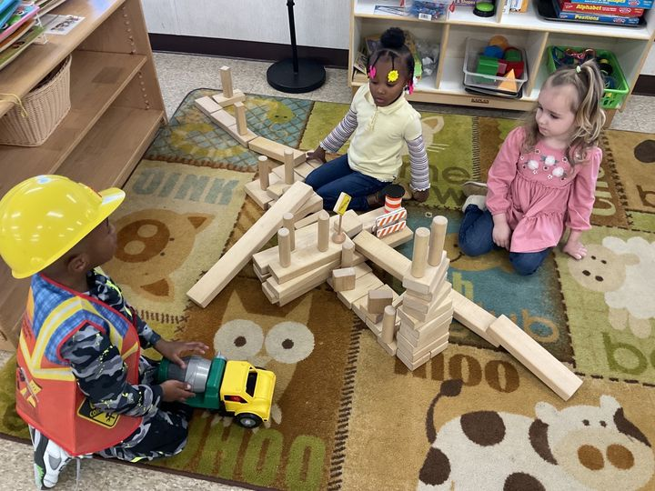
throughout the program from serving 4-year-4-quality program. 4
Mission and Goals

MISSION STATEMENT
Transforming walls into doors as our challenges
become opportunities to serve each other.

VISION STATEMENT
Cheaha Regional Head Start is innovative in leading the way-providing a comprehensive program of quality through respect and nurturing of children and families while setting standards of excellence.

Program Goals
Program Goal 1: CRHS will strengthen the reliability of child development assessment data by improving education systems including screening, assessment, and curriculum; teacher, behavior
Goal 1: | Goal 2: | Goal 3: | Goal 4: | Goal 5:
CRHS will strengthen the reliability of child development assessment data by improving education systems including screening, assessment, and curriculum; teacher evaluation and practice-based coaching, behavior management and interventions practices. | Families will increase their knowledge of positive parenting skills to promote their children’s development and reduce parent stress. | CRHS will increase employee retention by evaluating, educating, and responding to employee wellness concerns within the program. | CRHS will strengthen transitions for children and families entering into Head Start and out of Head Start so that children succeed in kindergarten and beyond. | CRHS will improve the monitoring of program activities, including finance, on an ongoing basis to ensure mission, program goals and standards are being met and respond to data that requires corrections in the program plan.  .

g, behavior management and interventions practices.
5

Governance
The Governing Board

The TCR Board of Directors serves as the governing body for CRHS, overseeing the fiscal accounting of all Head Start funds, as well as monitoring effectiveness and progress in meeting local program goals and implementing federal requirements.

Policy Council

The CRHS Policy Council consists of parents and community members elected from parent committees within each center. The Policy Council members represent family concerns and approve financial expenditures and annual program planning.
Both governing bodies are trained in Head Start governance responsibilities, as well as fiscal and program policies and procedures.

6

Funding Sources and Budgetary Expenditures

COVID-19 Funding $1,125,634
Alabama Office of School Readiness $ 413,800

7

Reviews and Audits

From January 31, 2022, to February 4, 2022, the Administration for Children and Families (ACF) conducted a Focus Area Two (FA2) monitoring review. This report contains information about the recipient's performance and compliance with the requirements of the Head Start Program Performance Standards (HSPPS) or Public Law 110-134, Improving Head Start for School Readiness Act of 2007. The program had no deficiencies and only one area of concern. (see below) All recommendations and timelines for corrections have been met at the submission of this report.

- A review of the Head Start Teacher and Early Head Start Teacher Qualification Tracking form found 14 of 64 Early Head Start teachers did not have a minimum of a Child Development Associate (CDA) credential or comparable credential focused on infant and toddler development. These 14 teachers had hire dates between April and December 2021. Each of the teachers had a professional development plan (PDP) to obtain their CDA credentials with expected completion dates ranging from February to April 2022. The teachers' PDPs were monitored bi-weekly by the professional development specialist.

AOC 1302.91(e)(1) Timeframe for Correction: Follow up with Regional Office for support

The annual audit was completed for the fiscal year September 30, 2021 and there were no adverse findings.

8

Enrollment

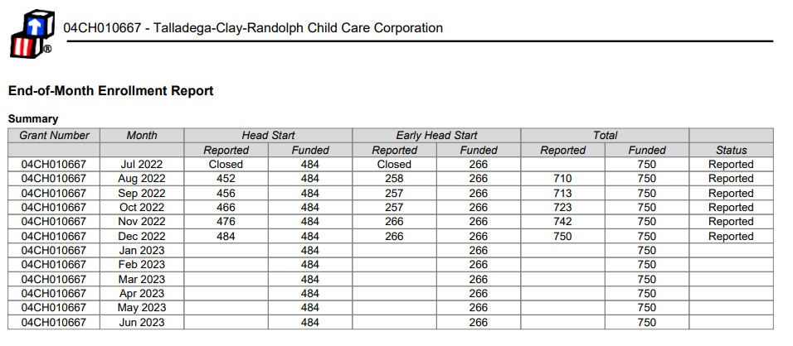
Program Totals = 750 100% Funded enrollment at submission of this report

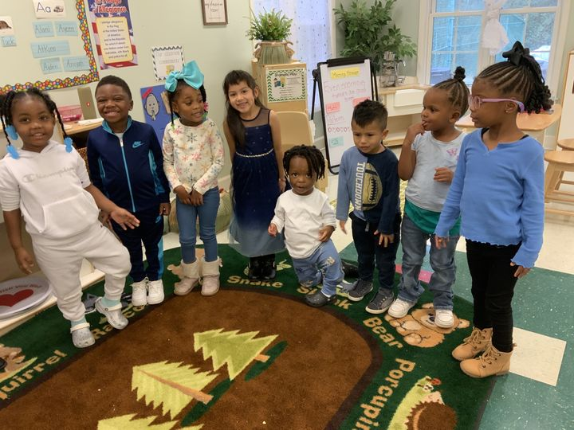
9

Enrollment by Income

Cheaha Regional Head Start
2250 - Enrollment and Waitlist Charts
Program Term: Early Head Start 2022-2023
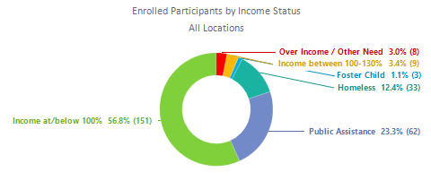
Cheaha Regional Head Start
2250 - Enrollment and Waitlist Charts
Program Term: Head Start 2022-2023
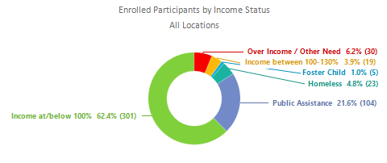

10

Waitlist by Income

Cheaha Regional Head Start
2250 - Enrollment and Waitlist Charts
Program Term: Early Head Start 2022-2023
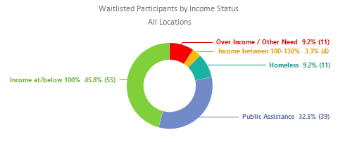

Cheaha Regional Head Start
2250 - Enrollment and Waitlist Charts
Program Term: Head Start 2022-2023
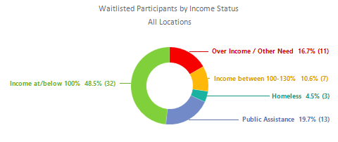
11

Health Services
Cheaha Regional Head Start and Early Head Start programs maintain a Health Services Advisory Committee to support children’s healthy development. The HSAC is an advisory group composed of local health providers who represent a wide variety of local social services agencies. They include pediatricians, nurses, nurse practitioners, dentists, nutritionists, and mental health providers. Head Start staff and parents also serve on the HSAC. Effective partnerships are key to the success of this approach. HSACs help programs to make decisions about health services and strengthen the communities where Head Start families live.

Nutrition Services
CRHS encourages good nutrition by working with parents, staff, and local nutritionists to address the nutritional needs of all children, especially those with special dietary needs. Additionally, all classrooms eat meals in family-style settings.
CRHS and the Alabama Department of Public Health formed a partnership to provide on-site WIC services at our Constantine Head Start and Talladega centers. These two offices discontinued services on-site during the COVID pandemic. The expectation is that the services will resume onsite at these two centers August 2023.

12

Parent Involvement
CRHS’s Head Start program provides families with opportunities to be a part of their child’s learning development in numerous ways.
To incorporate Family Engagement:

- Monthly Parent Conscious Discipline training at each Head Start site
- 24/7 Dads Program to increase male participation
- Workshops are conducted on topics such as: finances, employment, parenting, nutrition classes, etc.
- Phone calls will be made, and surveys conducted to ensure family’s well-being.
- Learning Genie is an all-in-One Data Driven Family Engagement Suite featuring two-way communication with auto-translation, family engagement tool offered and encouraged to all families for increased communication, and engagement

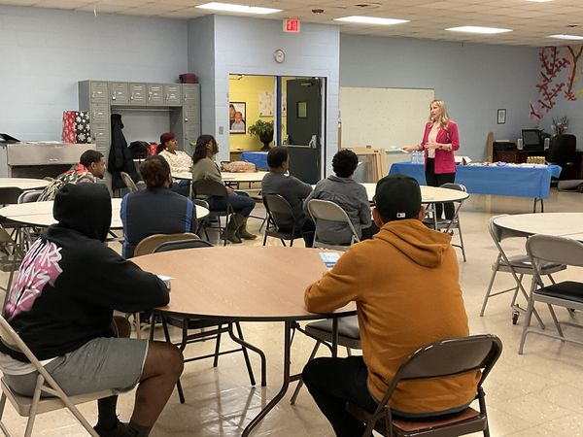

13

Family Outcomes
Cheaha Regional Head Start provides tangible child development supports and resources that families and staff want and need. They work with families and Head Start and Early Head Start staff toward such goals. These include parents’ educational advancement, economic mobility, and other aspects of family well-being. Family outcomes are tracked in the ChildPlus data system. (see below)
 |  | Services Received
Early Head Start
43. The number of families that received the following program service to promote family outcomes:
a. Emergency/crisis intervention such as addressing immediate need for food, clothing, or shelter |  | 3
b. Housing assistance such as subsidies, utilities, repairs, etc. |  | 1
c. Asset building services (e.g. financial education, debt counseling) |  | 1
d. Mental health services |  | 0
e. Substance misuse prevention |  | 0
f. Substance misuse treatment |  | 0
g. English as a second language (ESL) training |  | 0
h. Assistance in enrolling into an education or job training program |  | 2
i. Research-based parenting curriculum |  | 12
j. Involvement in discussing their child's screening and assessment results and their child's progress |  | 241
k. Supporting transitions between programs (i.e. EHS to HS, HS to kindergarten) |  | 21
l. Education on preventative medical and oral health |  | 24
m. Education on health and developmental consequences of tobacco product use |  | 8
n. Education on nutrition |  | 16
o. Education on postpartum care (e.g. breastfeeding support) |  | 9
p. Education on relationship/marriage |  | 0
q. Assistance to families of incarcerated individuals |  | 0
44. Of these, the number that received at least one of the services listed above |  | 249
 |  | Services Received
Head Start
43. The number of families that received the following program service to promote family outcomes:
a. Emergency/crisis intervention such as addressing immediate need for food, clothing, or shelter |  | 9
b. Housing assistance such as subsidies, utilities, repairs, etc. |  | 2
c. Asset building services (e.g. financial education, debt counseling) |  | 0
d. Mental health services |  | 1
e. Substance misuse prevention |  | 0
f. Substance misuse treatment |  | 0
g. English as a second language (ESL) training |  | 0
h. Assistance in enrolling into an education or job training program |  | 0
i. Research-based parenting curriculum |  | 26
j. Involvement in discussing their child's screening and assessment results and their child's progress |  | 439
k. Supporting transitions between programs (i.e. EHS to HS, HS to kindergarten) |  | 11
l. Education on preventative medical and oral health |  | 42
m. Education on health and developmental consequences of tobacco product use |  | 0
n. Education on nutrition |  | 16
o. Education on postpartum care (e.g. breastfeeding support) |  | 0
p. Education on relationship/marriage |  | 0
q. Assistance to families of incarcerated individuals |  | 0
44. Of these, the number that received at least one of the services listed above |  | 442
14

School Readiness
School Readiness Goals 2022-2023
Domain | Goal
Physical Development and Health | Performs activities that combine and coordinate large muscle movements, including swinging on a swing, climbing a ladder, or dancing to music.
Social Emotional Development | Seeks help from adults when needed.
Approaches to Learning | Has an expanding range of strategies for managing emotions, both less intense emotions as well as those that cause greater distress. May still look to adults for support in managing the most intense emotions but shows increasing skill in successfully using strategies suggested by adults.
Language and Literacy Development | Shows a steady increase in vocabulary through the acquisition of words with increasing specificity and variety. Shows repetition of new words offered by adults and may ask about the meaning of unfamiliar words.
English Language Development | With support, provides basic answers to specific questions about details of a story, such as who, what, when, or where. With support, can answer inferential questions about stories, such as predictions or how/why something is happening in a particular moment.
Cognition and General Knowledge | Stops an engaging activity to transition to another less desirable activity with adult guidance and support.  1b: Follows limits and expectations
Mathematics | Counts verbally or signs to at least 20 by ones.
Science and Technology | Identifies the five senses (smell, touch, sight, sound, taste) and uses them to make observations.
The Arts | Develops more elaborate imaginary play, stories, and other creative works with children and adults.  14b: Engages in sociodramatic play
Social Studies | Identifies self as being a part of different groups, such as family, community, culture, faith, or preschool.
English Language Acquisition | Shows an ability to recall (in order) multiple step directions.
15

Disability Services
Cheaha Regional Head Start makes ongoing recruitment and enrollment efforts to ensure that children with disabilities and their families are enrolled and have access to high-quality early childhood services. Every effort is made to ensure that at least 10% of total funded enrollment slots are occupied by children eligible for services under the Individuals with Disabilities Education Act (IDEA). The 10% requirement was met for the 2021-2022 program year and at submission of this report is at the 8.9% mark.
- Early Head Start: 18 IFSPs (+2 expired waiting on renewal)
- Head Start: 49 IEPs (+2 expired waiting on renewal)
- Early Head Start pending evaluation: 16
- Head Start pending evaluation: 41

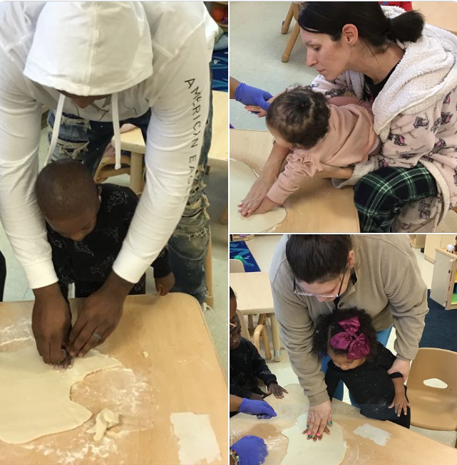
16

Teacher Qualifications

17

